**Plot of Cumulative Incidence for Competing Risk Analysis by Fine & Gray Model**

**Macro:** %Plots_CIF

**Created Date/Author:** Sep 23, 2016/Yaqi Jia

**Last Update Date/Person**: Oct 2016/Chao Zhang

**Current Version**: V2

**Working Environment:** SAS 9.4 English version

**Contact**: Dr. Yuan Liu [yliu31@emory.edu](mailto:yliu31@emory.edu)

**Purpose:** To create a cumulative incidence plot. The proportional subdistribution hazards model as proposed by Fine and Gray (1999) was used.

**Notes:** The model runs using PROC PHREG.

**Reference**: Fine, J. P. and Gray, R. J. (1999), “A Proportional Hazards Model for the Subdistribution of a Competing Risk,” Journal of the American Statistical Association, 94, 496–509.

**Parameters:**

|  |  |
| --- | --- |
| **Macro variable** | **Description** |
| DSN | The name of the data set to be analyzed. |
| TIME_EVENT | Name of time to event outcome variable. |
| CENSOR | Name of censoring indicator variable. Values of 0 indicate censored. |
| EVENTCODE | The value in CENSOR that indicate event of interest, and this value will appear EVENTCODE= option. The default value is 1. |
| GRPLIST | The variable list that defines the groups for comparison (optional). |
| YAXISVALUE | Specify the ticket of y axis. The default value is (0 .1 .2 .3 .4 .5 .6 .7 .8 .9 1.0); |
| XAXISVALUE | Usage xaxisvalue = 0 12 24 36 ...; specify the ticket value of X axis. |
| TIMELIST | List of time points separated by spaces to report survival estimates and 95% CI (optional). Note that this is not currently set up to work without a strata variable. |
| UNITS | Units of the time variable, i.e. days, months, etc. The default value is none. |
| FNAME | File name for output table. |
| OUTPATH | File path for output table to be stored. |
| DEBUG | Set to T if running in debug mode (optional). Work datasets will not be deleted in debug mode. This is useful if you are editing the code or want to further manipulate the resulting data sets. The default value is F. |

**Usage Example:**

**proc** **format**;

value DiseaseGroup **1**='ALL' **2**='AML-Low Risk' **3**='AML-High Risk';

run;

**data** Bmt;

input Disease T Status @@;

label T='Disease-Free Survival in Days';

format Disease DiseaseGroup.;

datalines;

1 2081 0 1 1602 0 1 1496 0 1 1462 0 1 1433 0

1 1377 0 1 1330 0 1 996 0 1 226 0 1 1199 0

1 1111 0 1 530 0 1 1182 0 1 1167 0 1 418 2

1 383 1 1 276 2 1 104 1 1 609 1 1 172 2

1 487 2 1 662 1 1 194 2 1 230 1 1 526 2

1 122 2 1 129 1 1 74 1 1 122 1 1 86 2

1 466 2 1 192 1 1 109 1 1 55 1 1 1 2

1 107 2 1 110 1 1 332 2 2 2569 0 2 2506 0

2 2409 0 2 2218 0 2 1857 0 2 1829 0 2 1562 0

2 1470 0 2 1363 0 2 1030 0 2 860 0 2 1258 0

2 2246 0 2 1870 0 2 1799 0 2 1709 0 2 1674 0

2 1568 0 2 1527 0 2 1324 0 2 957 0 2 932 0

2 847 0 2 848 0 2 1850 0 2 1843 0 2 1535 0

2 1447 0 2 1384 0 2 414 2 2 2204 2 2 1063 2

2 481 2 2 105 2 2 641 2 2 390 2 2 288 2

2 421 1 2 79 2 2 748 1 2 486 1 2 48 2

2 272 1 2 1074 2 2 381 1 2 10 2 2 53 2

2 80 2 2 35 2 2 248 1 2 704 2 2 211 1

2 219 1 2 606 1 3 2640 0 3 2430 0 3 2252 0

3 2140 0 3 2133 0 3 1238 0 3 1631 0 3 2024 0

3 1345 0 3 1136 0 3 845 0 3 422 1 3 162 2

3 84 1 3 100 1 3 2 2 3 47 1 3 242 1

3 456 1 3 268 1 3 318 2 3 32 1 3 467 1

3 47 1 3 390 1 3 183 2 3 105 2 3 115 1

3 164 2 3 93 1 3 120 1 3 80 2 3 677 2

3 64 1 3 168 2 3 74 2 3 16 2 3 157 1

3 625 1 3 48 1 3 273 1 3 63 2 3 76 1

3 113 1 3 363 2

;

**data** bmt; set bmt; call streaminit(**123**);

u = rand("Uniform");

if u>=**0.7** then Sex='Female'; else if u<**0.5** then Sex='Male';

if u>=**0.4** then Race='white'; else Race='AA';

call streaminit(**456**); Age = rand("Uniform")\***90**;

Drop u;

**run**;

%let dir = C:\;

Title " Fig 1 Plot of CIF for different patient groups " ;

%***Plots_CIF***(dsn=bmt,

grplist=group race,

time_event=t, censor=status,

eventcode=**1**,

title1=Cumulative Incidence Function,

xaxisvalue=**0** **200** **400** **600** **800** **1000** ,

yaxisvalue=**0** **0.1** **0.2** **0.3** **0.4** **0.5** ,

timelist= **60** **100** ,

units= Mo,

filename= Plot of CIF for different patient groups,

outpath= &dir.\ ,

debug=F)

Title ;

**Summary Plots Example:**

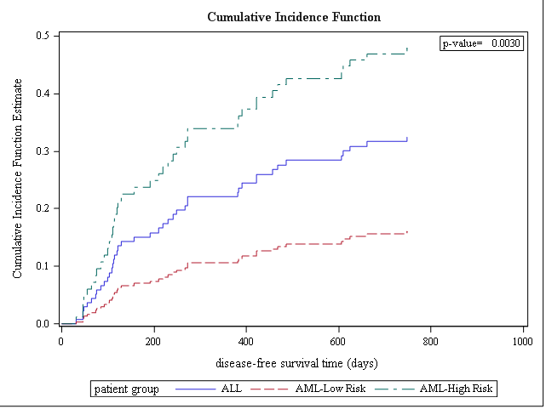

| **patient group** | **Time (Mo)** | **CIF Estimate (95% CI)** |
| --- | --- | --- |
| ALL | 60 | 3.66% (1.45%, 9.26%) |
|  | 100 | 8.16% (4.41%, 15.11%) |
| AML-High Risk | 60 | 6.02% (2.33%, 15.57%) |
|  | 100 | 13.19% (6.87%, 25.35%) |
| AML-Low Risk | 60 | 1.66% (0.65%, 4.23%) |
|  | 100 | 3.74% (1.95%, 7.17%) |

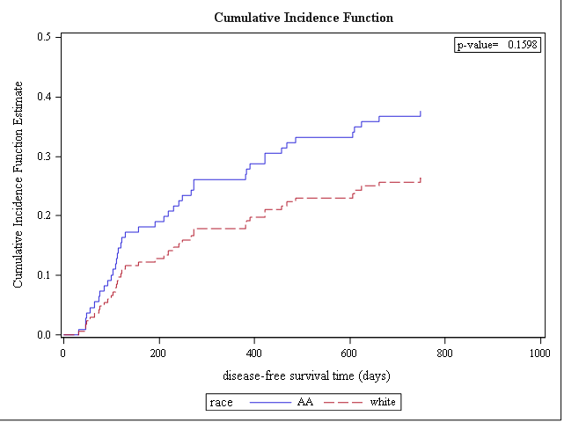

| **race** | **Time (Mo)** | **CIF Estimate (95% CI)** |
| --- | --- | --- |
| AA | 60 | 4.63% (1.82%, 11.79%) |
|  | 100 | 10.12% (5.83%, 17.54%) |
| white | 60 | 3.04% (1.29%, 7.17%) |
|  | 100 | 6.71% (3.56%, 12.65%) |

**Permission:**

Permission is hereby granted, free of charge, to any person obtaining a copy of this software and associated documentation files (the "Software"), to deal in the Software without restriction, including without limitation the rights to use, copy, modify, merge, publish, distribute, sublicense, and/or sell copies of the Software, and to permit persons to whom the Software is furnished to do so, subject to the following conditions:   
  
The above copyright notice and this permission notice shall be included in all copies or substantial portions of the Software.  
  
THE SOFTWARE IS PROVIDED "AS IS", WITHOUT WARRANTY OF ANY KIND, EXPRESS OR IMPLIED, INCLUDING BUT NOT LIMITED TO THE WARRANTIES OF MERCHANTABILITY, FITNESS FOR A PARTICULAR PURPOSE AND NONINFRINGEMENT. IN NO EVENT SHALL THE AUTHORS OR COPYRIGHT HOLDERS BE LIABLE FOR ANY CLAIM, DAMAGES OR OTHER LIABILITY, WHETHER IN AN ACTION OF CONTRACT, TORT OR OTHERWISE, ARISING FROM, OUT OF OR IN CONNECTION WITH THE SOFTWARE OR THE USE OR OTHER DEALINGS IN THE SOFTWARE.

**Log of Updates:**

|  |  |  |  |
| --- | --- | --- | --- |
| **Date** | **By** | **Description** | **Version** |
| Mar, 2016 | Yaqi Jia | Initial Creation | V1 |
| Oct, 2016 | Chao Zhang | Simplify macro; directly use Proc Phreg to create the plot. Reduce some parameters of the macro. | V2 |